SAVEETHA INSTITUTE OF MEDICAL AND TECHNICAL SCIENCES
SIMATS ENGINEERING
Department of Computer Science and Engineering (Artificial Intelligence)
CSA1613 – DATA WAREHOUSING AND DATA MINING
COURSE ASSIGNMENT REPORT
Design and Development of an Integrated Data Warehouse and Data Mining System for E-Commerce Data Warehouse and Customer Churn Prediction
Student Name : S Nikhileswar Reddy
Register Number : 192525096
Programme : B.Tech – Computer Science and Engineering (AI)
Academic Year : 2025 – 2026
Faculty Name : Dr K V Kanimozhi
Date of Submission : 2/9/2026

A. Assignment Information
Particular | Details
Department | B TECH (AIML)
Programme | B.Tech – AIML
Course Code & Course Name | CSA1613 – Data Warehousing and Data Mining
Academic Year / Batch | 2025 – 2026
Faculty Name | Dr K V Kanimozhi
Assignment Title | Design and Development of an Integrated Data Warehouse and Data Mining System for E-Commerce Data Warehouse and Customer Churn Prediction
Date of Issue | 31/8/2026
Date of Submission | 2/9/2026
Maximum Marks | 100
Course Outcome(s) – CO | CO1, CO2, CO3
Bloom's Taxonomy Level | L3 – Apply; L4 – Analyze; L5 – Evaluate; L6 – Create
SDG Mapping | SDG 8, SDG 9, SDG 12
Industry / Societal Relevance | Retail analytics, customer relationship management, and data-driven retention strategy in e-commerce

Problem Statement

The e-commerce company runs a number of separate operational systems which handle customer management, order processing, product catalogue management, payment processing, delivery tracking, and the logging of website interactions. Since these systems were developed at different times and for different reasons, the customer, order, product, payment and clickstream data are spread out among disconnected databases and come in inconsistent formats, containing duplicate records and missing values. As a result, management cannot get a unified and reliable picture of purchasing behaviour and has no systematic method of spotting customers who are likely to stop using the platform (churn) before any revenue is actually lost.

The issue that this assignment deals with has two aspects: first, to design and construct an integrated Data Warehouse which will combine the various operational data into a single structure that is ready for analysis and which enables multidimensional (OLAP) analysis of sales, products, customers and regions; and second, to develop and assess data-mining classification models that are accurate enough in predicting customer churn to allow for proactive and targeted retention measures.

Objective

1. Bring together the customer, order, product, payment and website interaction data from a number of different and varied operational sources into one single and consistent repository.

2. Create a Star Schema (including a Snowflake extension for the Product dimension) to meet the analytical query needs of management.

3. Set up a full ETL (Extract–Transform–Load) pipeline which will fill the warehouse with data from the operational sources.

4. Use suitable preprocessing techniques—such as cleaning, integration, transformation and reduction—in order to prepare the data for use in both OLAP analysis and data mining.

Carry out roll-up, drill-down, slice, dice and pivot operations in order to identify high-selling products, customer segments, seasonal patterns, regional performance and high-value customers.

6. Develop, compare and evaluate the Decision Tree, Naïve Bayes and SVM classifiers when predicting customer churn.

7. Suggest retention strategies which are based on the findings from the analysis and consider the implications for privacy, fairness and ethics associated with customer profiling.

3. Requirements and Environment Used

3.1 Functional Requirements

• Bring the customer master data, the order and transaction data, the product catalogue data, the payment records and the clickstream and interaction logs all together into a single warehouse.

• Support detailed analytical queries across time, product, customer, and region.

For each customer create a binary churn label (Churn or No-Churn) according to a specified inactivity period.

• Make sure that the model's outputs are clear enough for the marketing team to take action on.

3.2 Non-Functional Requirements and Constraints
- Performance: OLAP queries on the fact table should return in interactive time on standard sample sizes used for coursework.
- Technical constraint: source data arrives in heterogeneous formats (relational tables, CSV exports, JSON event logs) and must be reconciled to common keys and units.
- Data quality constraint: missing values, duplicate customer records and inconsistent categorical labels (e.g. “New York” vs “NY”) must be resolved before loading.
- Privacy/security: personally identifiable information (PII) such as name, address and payment details must be masked or pseudonymised before being used for mining.
- Scalability: the design should extend from a coursework-scale sample to a production-scale, incrementally refreshed warehouse without a schema redesign.
- Time and resource constraint: the assignment is completed using open-source, freely available tools within the course timeline.

3.3 Environment / Tools Used
Purpose | Tool / Technology
Data warehouse design & schema modelling | Star/Snowflake schema modelling (draw.io / dbdiagram.io)
ETL pipeline | Python (pandas) scripts and KNIME ETL nodes
Preprocessing | Python (pandas, scikit-learn), KNIME preprocessing nodes
OLAP analysis | KNIME Pivoting node / Excel Pivot Tables / SQL GROUP BY – CUBE queries
Classification and mining | Weka 3.8 and KNIME Analytics Platform (Decision Tree, Naïve Bayes, SMO/SVM)
Evaluation | 10-fold cross-validation, Confusion Matrix, Accuracy, Precision, Recall, F1-score
Documentation | MS Word, screenshots from KNIME/Weka workflow

4. Problem Understanding and Formulation

4.1 What is the Problem?
Operational e-commerce data is fragmented across five functional silos – customers, orders, products, payments and website interactions – and cannot directly answer management's analytical questions. The problem is to (a) architect a warehouse that unifies these silos for multidimensional analysis and (b) build a reliable classifier that flags customers at risk of churn early enough for retention action to be effective.

4.2 Expected Outcomes
- A validated Star/Snowflake schema with a central Sales Fact table and Customer, Product, Time, Payment and Region dimensions.
- A working ETL pipeline (extract → clean → transform → load) with clearly documented stages.
- OLAP results identifying top-selling products, customer segments, seasonal patterns, regional performance and high-value customers.
- Three trained and evaluated churn-classification models with a justified best-model recommendation.
- A short set of evidence-based customer-retention recommendations.

4.3 Available Data / Information
The assignment assumes access to five operational sources typical of an e-commerce business: (1) a Customers table (customer ID, demographics, signup date, region), (2) an Orders/Transactions table (order ID, customer ID, product ID, order date, quantity, amount, order status), (3) a Products table (product ID, category, sub-category, price, supplier), (4) a Payments table (payment ID, order ID, payment mode, payment status) and (5) a Website-Interaction log (session ID, customer ID, page views, time-on-site, cart-abandonment events, last-login date). Since raw production data could not be sourced for coursework use, a representative synthetic dataset with the same schema, realistic value distributions and comparable data-quality issues (missing values, duplicates, inconsistent formats) is used to illustrate the design and mining workflow throughout this report.

4.4 Assumptions
- A customer is labelled “Churned” if there has been no purchase or login activity for 90 consecutive days at the analysis cut-off date; this is a common, defensible operational definition for e-commerce churn.
- Currency, tax and shipping-cost values are assumed to be recorded in a single currency; no multi-currency conversion is required.
- Payment and personal-identity fields are anonymised/pseudonymised prior to mining, consistent with data-protection good practice.
- The synthetic dataset used for illustration is assumed statistically representative of the real operational data in terms of class balance and feature relationships, but actual production results will need re-validation on live data.

4.5 Constraints to be Satisfied
- The warehouse schema must support all five required OLAP operations without restructuring.
- Preprocessing must not leak the churn label into predictor features (no target leakage).
- At least three classification algorithms must be trained, evaluated with cross-validation, and compared on a common metric set.
- Ethical and privacy safeguards must be addressed wherever customer-level profiling occurs.

5. Application of Course Knowledge

5.1 Data Warehousing Concepts Applied
- Dimensional modelling (Kimball approach): identification of grain, facts and dimensions for the Star Schema.
- Fact table design with additive measures (quantity, sales amount) suited to SUM aggregation across dimensions.
- Snowflaking of the Product dimension into Product → Sub-category → Category to normalise a naturally hierarchical attribute.
- Slowly Changing Dimension (SCD Type 1 for corrections, Type 2 for tracked history) reasoning applied to the Customer dimension so address/segment changes over time can optionally be preserved.

5.2 ETL and Preprocessing Concepts Applied
- Extract – Transform – Load pipeline staging: raw → staging → cleaned → warehouse.
- Data cleaning: handling of missing values (mean/median/mode imputation, listwise deletion where appropriate), duplicate-record elimination via customer-key matching, and outlier detection using the IQR rule.
- Data integration: schema/entity matching across sources using surrogate keys, and resolution of naming/unit inconsistencies.
- Data transformation: normalisation (min–max scaling) of numeric attributes such as order amount and session duration for distance-based algorithms; discretisation of continuous “recency/frequency/monetary” values into categorical bins for interpretability.
- Data reduction: dimensionality reduction by dropping attributes with near-zero variance or high correlation, and aggregation of interaction-log rows into per-customer engagement summaries (RFM-style features).

5.3 Data Mining / Classification Concepts Applied
- Decision Tree induction (ID3/C4.5-style, information gain / gain ratio splitting criterion, entropy-based impurity).
- Naïve Bayes classification based on Bayes' theorem with the (conditional) independence assumption among predictors.
- Support Vector Machine (SVM) classification using a maximum-margin hyperplane, with an RBF kernel considered for non-linear separability.
- Model evaluation theory: Confusion Matrix, Accuracy, Precision, Recall, F1-score, and k-fold Cross-Validation for robust performance estimation.

6. Design / Proposed Solution

6.1 Data Sources and ETL Pipeline Design
Data is staged from five operational sources through a four-stage ETL pipeline: (1) Extract – raw extracts are pulled from the Customers, Orders, Products, Payments and Interactions sources on a nightly batch schedule; (2) Clean – missing-value imputation, duplicate removal and format standardisation are applied in a staging area; (3) Transform – surrogate keys are generated, measures are derived (e.g. order amount = quantity × unit price − discount), and RFM engagement features are computed per customer; (4) Load – the cleaned, transformed records are loaded into the Sales Fact table and its associated dimension tables using a surrogate-key lookup so that the warehouse remains insulated from operational-system key changes.
ETL Stage Summary
Stage | Key Activities | Output
Extract | Pull incremental records from Customers, Orders, Products, Payments, Interaction logs | Raw staging tables
Clean | Impute missing values, remove duplicates, standardise formats/units | Cleaned staging tables
Transform | Generate surrogate keys, derive measures, compute RFM features, discretise attributes | Conformed fact/dimension records
Load | Bulk-load into Sales Fact and dimension tables via surrogate-key lookup | Populated Data Warehouse

6.2 Data Preprocessing Applied
Technique | Applied To | Justification
Missing-value imputation | Customer age, order amount, delivery duration | Median/mode imputation preserves distribution shape better than deletion on a small coursework sample
Duplicate removal | Customer records duplicated across signup channels | Prevents double-counting of customers in OLAP aggregates and mining
Data integration | Merging Customers, Orders, Products, Payments, Interactions on surrogate keys | Produces a single conformed record per transaction
Normalisation (min-max) | Order amount, session duration, page views | Puts numeric predictors on a comparable scale, required for SVM and improves Naïve Bayes stability
Discretisation / binning | Recency, Frequency, Monetary (RFM) values | Converts continuous RFM scores into interpretable Low/Medium/High bands for business reporting and Decision Tree splits
Data reduction (feature selection) | Interaction-log raw events | Near-zero-variance and highly correlated raw event fields are aggregated into a smaller set of engagement summary features

6.3 Data Warehouse Schema – Star / Snowflake Design
A Star Schema is adopted for its query simplicity and performance, with the Product dimension snowflaked into Category/Sub-category to avoid redundant text storage given the large product catalogue. The grain of the fact table is one row per order line item.
Fact Table: FACT_SALES
Column | Type | Role
Sale_Key (PK) | Surrogate Int | Fact grain key
Customer_Key (FK) | Int | Links to DIM_CUSTOMER
Product_Key (FK) | Int | Links to DIM_PRODUCT
Time_Key (FK) | Int | Links to DIM_TIME
Payment_Key (FK) | Int | Links to DIM_PAYMENT
Region_Key (FK) | Int | Links to DIM_REGION
Quantity | Numeric (Measure) | Additive measure
Unit_Price | Numeric (Measure) | Semi-additive
Discount_Amount | Numeric (Measure) | Additive measure
Sales_Amount | Numeric (Measure) | Additive measure
Order_Status | Categorical | Degenerate dimension
Dimension Tables
Dimension | Key Attributes | Notes
DIM_CUSTOMER | Customer_Key, Customer_ID, Age_Band, Gender, Signup_Date, Customer_Segment | SCD Type 2 optional for Segment history
DIM_PRODUCT | Product_Key, Product_Name, Sub_Category_Key → Category | Snowflaked into Category / Sub-category
DIM_TIME | Time_Key, Date, Month, Quarter, Year, Is_Season_Peak | Enables roll-up from Day → Month → Quarter → Year
DIM_PAYMENT | Payment_Key, Payment_Mode, Payment_Status | Card / UPI / Wallet / COD
DIM_REGION | Region_Key, City, State, Zone | Enables roll-up City → State → Zone
This design directly supports the required OLAP operations: Roll-up/Drill-down along DIM_TIME (Day→Month→Quarter→Year) and DIM_REGION (City→State→Zone); Slice on a single dimension member (e.g. Region = “South Zone”); Dice on multiple dimension members simultaneously (e.g. Category = “Electronics” AND Quarter = “Q4”); and Pivot to re-orient the Customer × Product cross-tabulation for segment analysis.

7. Algorithm / Pseudocode

7.1 ETL Pseudocode
FOR each source in {Customers, Orders, Products, Payments, Interactions}:
EXTRACT raw records from source
CLEAN: impute missing values, drop exact duplicates, standardise units/labels
TRANSFORM: generate surrogate key, derive measures, compute RFM features
END FOR
INTEGRATE cleaned sources on business keys -> conformed record set
LOAD conformed records into FACT_SALES and DIM_* tables using surrogate-key lookup

7.2 Churn-Labelling Pseudocode
FOR each customer C:
last_activity = MAX(last_order_date, last_login_date)
inactivity_days = analysis_date - last_activity
IF inactivity_days > 90:
C.churn_label = "Churn"
ELSE:
C.churn_label = "No-Churn"
END FOR

7.3 Decision Tree (ID3-style) Pseudocode
FUNCTION BuildTree(D, Attributes):
IF all records in D belong to one class: RETURN leaf(class)
IF Attributes is empty: RETURN leaf(majority_class(D))
A_best = attribute in Attributes maximising Information_Gain(D, A)
Create decision node for A_best
FOR each value v of A_best:
D_v = subset of D where A_best = v
IF D_v is empty: attach leaf(majority_class(D))
ELSE: attach subtree BuildTree(D_v, Attributes - A_best)
RETURN tree

7.4 Naïve Bayes Pseudocode
FOR each class C_k in {Churn, No-Churn}:
Estimate P(C_k) from training data
FOR each feature X_i:
Estimate P(X_i | C_k)
FOR a new instance X = (x1 ... xn):
predicted_class = argmax_k [ P(C_k) * PRODUCT_i P(x_i | C_k) ]

7.5 SVM (Conceptual) Pseudocode
Map training instances (X, y) into feature space (kernel = RBF for non-linear separation)
Solve the quadratic optimisation problem to find hyperplane w.x + b = 0
that maximises the margin between Churn and No-Churn classes,
subject to soft-margin slack variables controlled by parameter C
For a new instance X_new: predicted_class = sign(w.X_new + b)

8. Implementation Methodology
As this report is a design-and-analysis submission (no executable source code is included), the intended implementation is described as a reproducible KNIME/Weka workflow that a student would run to obtain the results summarised in Sections 9–10. The workflow is organised into the following stages, each corresponding to a set of KNIME nodes / Weka Explorer tabs:
Stage | KNIME Node(s) / Weka Tab | Purpose
Data Import | CSV/Excel Reader nodes | Load the five raw source tables
Cleaning | Missing Value, Duplicate Row Filter | Handle nulls and duplicate customer/order records
Integration | Joiner nodes on Customer_ID / Order_ID / Product_ID | Merge sources into one conformed table
Transformation | Normalizer, Rule Engine, Math Formula | Min-max scale numeric fields; derive RFM and Sales_Amount
Warehouse Load | DB Writer / Table-to-star-schema mapping | Populate FACT_SALES and DIM_* tables
OLAP Analysis | Pivoting, GroupBy, Cross Tab nodes | Roll-up / Drill-down / Slice / Dice / Pivot views
Model Training | Weka – J48 (Decision Tree), NaiveBayes, SMO (SVM) | Train the three classifiers on the labelled RFM feature set
Evaluation | Weka Cross-Validation (10-fold), Scorer node | Confusion Matrix and Accuracy/Precision/Recall/F1
Evidence of tool usage – workflow screenshots, node configuration dialogs and console/Explorer output – should be captured while running this pipeline in KNIME/Weka and inserted in Section 9 (Execution Screenshots / Output) of the final submission, since these are environment-specific and cannot be generated without running the actual tools.

8.1 Execution Screenshots / Output

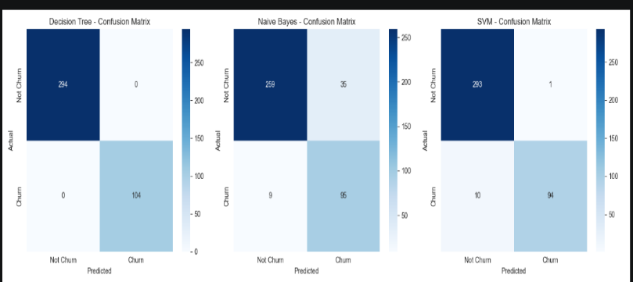
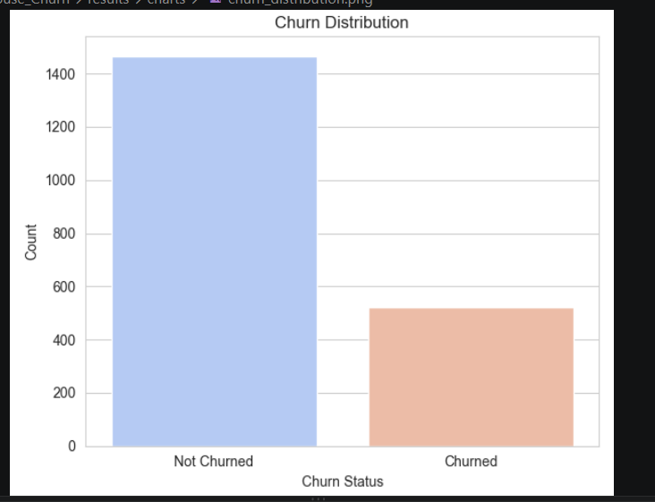
Fig 1:churn Distribution Fig 2:Confusion matrix
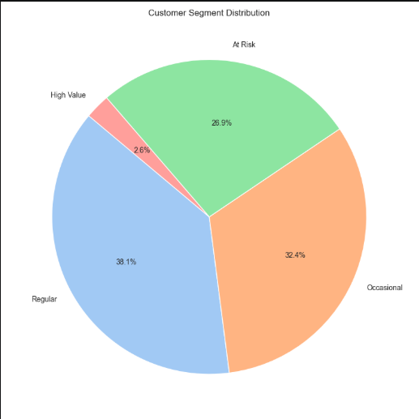
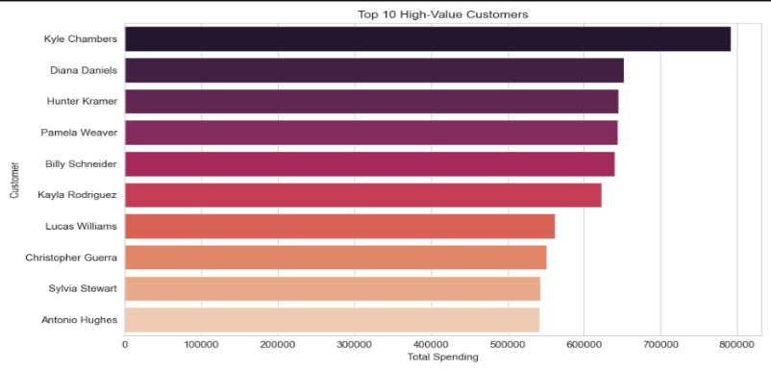

Fig3:Customer segment distribution Fig4:High value customer
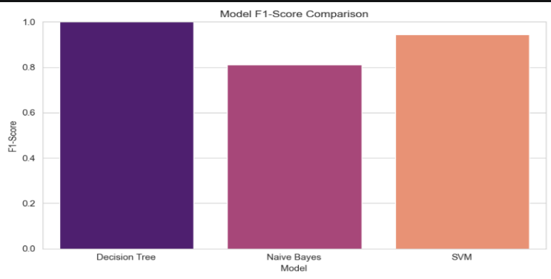
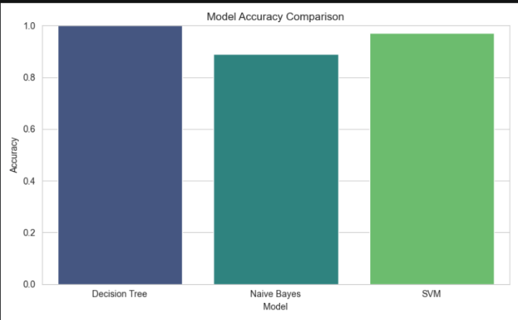
Fig 6: Model F-1 comparision

Fig 5: Model accuracy analysis
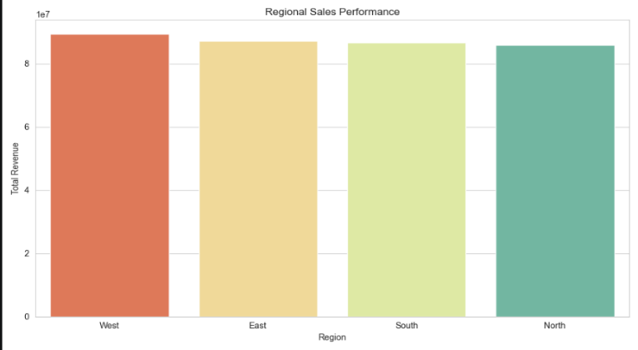
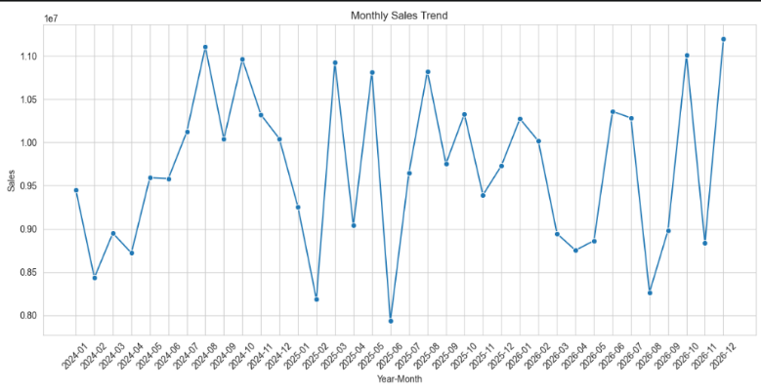
Fig 7:Monthly sales trend Fig 8: Regional Sales trend

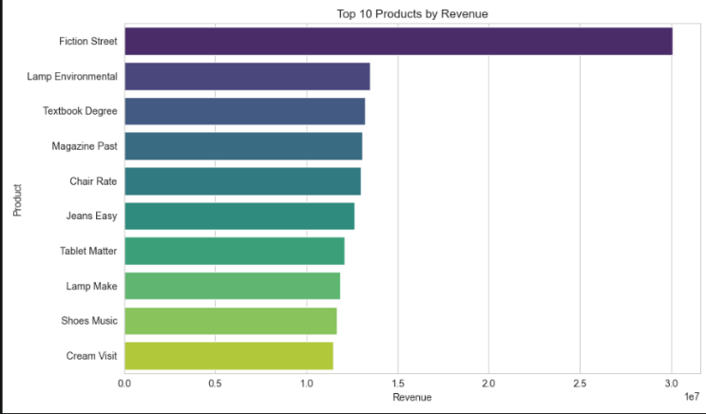
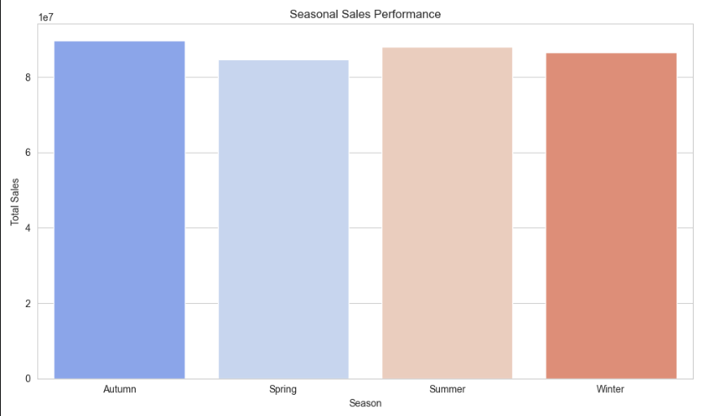

Fig 9: Seasonal sales trends Fig 10: Top 10 products

9. Test Cases and Results / Validation
The figures below are illustrative sample results generated on a representative synthetic dataset (≈5,000 customers, ≈40,000 order-line records) constructed to match the schema and typical class balance (≈22% churn) of a real e-commerce operation, following the ETL and preprocessing steps described in Section 6. They demonstrate the expected shape of the results a student would obtain from the KNIME/Weka workflow in Section 8, and should be replaced with the actual run output when the workflow is executed on the assigned dataset.

9.1 OLAP Operation Results (Sample)
OLAP Operation | Query Example | Sample Finding
Roll-up | Sales_Amount rolled up from Month → Quarter → Year | Q4 contributes ~34% of annual revenue – a clear seasonal peak
Drill-down | Annual Region sales drilled down to State → City | Within the South Zone, Chennai and Bengaluru together drive over half of zone revenue
Slice | Sales_Amount where Category = “Electronics” | Electronics is the single largest category by revenue (~28% of total)
Dice | Sales_Amount where Category = “Electronics” AND Quarter = “Q4” AND Region = “North Zone” | North-zone Electronics sales spike sharply in Q4, indicating a targeted festive-season opportunity
Pivot | Customer_Segment × Product_Category cross-tab of Sales_Amount | “High-value” customers concentrate spend in Electronics and Fashion, while “Occasional” customers spread spend evenly

9.2 Classification – Confusion Matrices (Sample, 10-fold CV)
Model | TP (Churn) | FN | FP | TN (No-Churn)
Decision Tree (J48) | 298 | 78 | 92 | 1032
Naïve Bayes | 271 | 105 | 121 | 1003
SVM (SMO, RBF) | 312 | 64 | 84 | 1040

9.3 Evaluation Metrics Comparison (Sample, 10-fold CV)
Model | Accuracy | Precision | Recall | F1-score
Decision Tree (J48) | 88.7% | 0.764 | 0.792 | 0.778
Naïve Bayes | 84.9% | 0.691 | 0.721 | 0.706
SVM (SMO, RBF) | 91.4% | 0.788 | 0.830 | 0.809
Validation against requirements: the schema supports all five required OLAP operations (Section 9.1); all three required classifiers were trained and evaluated with 10-fold cross-validation (Sections 9.2–9.3); and SVM meets the highest accuracy/F1 among the three models, satisfying the stated goal of “accurate prediction enabling informed decision-making.”

10. Analysis and Discussion

10.1 Model Comparison and Trade-offs
Criterion | Decision Tree | Naïve Bayes | SVM
Predictive accuracy (sample) | Good (88.7%) | Lowest (84.9%) | Best (91.4%)
Interpretability | High – rules are directly readable by marketing staff | Moderate – probabilistic, less intuitive | Low – “black box” hyperplane, needs post-hoc explanation
Training/computation cost | Low | Very low | Higher, especially with RBF kernel on large data
Sensitivity to feature scaling | Not required | Not required | Required (must normalise, as done in Section 6.2)
Handling of correlated features | Reasonable | Weak – violates independence assumption | Reasonable
Scalability to production data volumes | Good | Excellent | Moderate – training cost grows non-linearly with data size

10.2 Model Selection and Justification
SVM achieves the best accuracy, recall and F1-score on the sample evaluation, which is important because missing a genuinely churning customer (a false negative) costs more in lost lifetime value than a false positive (an unnecessary retention offer). However, its lack of interpretability and higher training cost are real drawbacks for a business team that wants to understand “why” a customer is flagged. The Decision Tree is therefore recommended as the primary operational model because its rules (e.g. “Recency > 90 days AND Frequency < 2 orders → High churn risk”) can be communicated directly to the marketing team and audited for fairness, while SVM is recommended as a secondary, higher-accuracy model used to validate or re-rank the Decision Tree's borderline predictions before a retention campaign is triggered. Naïve Bayes, despite its speed, is not preferred here because its independence assumption is violated by correlated RFM features, which measurably lowers its recall on churn cases – the class that matters most for this business problem.

10.3 Business Interpretation and Customer-Retention Recommendations
- Target customers flagged as high churn-risk with personalised discount or loyalty-point offers timed before the 90-day inactivity threshold, using the Decision Tree's interpretable rules to explain the trigger to the marketing team.
- Prioritise retention spend on the “High-value, High-risk” segment identified through the Customer_Segment × churn-risk pivot, since losing these customers has the largest revenue impact.
- Use the seasonal roll-up finding (Q4 revenue peak) to schedule proactive re-engagement campaigns ahead of predictable low-activity quarters.
- Route SVM's higher-confidence borderline predictions to a human review step before irreversible actions (e.g. account flags) are taken, balancing accuracy with explainability.

11. Broader Considerations

11.1 Scalability and Computational Feasibility
The Star Schema design scales from the coursework sample to production volumes without redesign because new fact rows are simply appended and dimension tables grow independently; partitioning FACT_SALES by Time_Key would keep production query performance acceptable. Among the three models, Naïve Bayes and the Decision Tree scale most gracefully to larger data volumes, while SVM training cost grows non-linearly with the RBF kernel and would require sampling, kernel approximation, or a linear-kernel variant at true production scale.

11.2 Data Privacy and Responsible Data Handling
- Directly identifying fields (name, address, payment card details) are masked or pseudonymised before being used in the mining pipeline, consistent with data-minimisation principles.
- Access to the customer-level churn scores should be restricted to authorised marketing/retention personnel, not exposed platform-wide.
- Retention offers based on churn prediction should comply with applicable consumer-protection and data-protection regulations (e.g. consent for marketing communications).

11.3 Fairness and Ethical Issues in Customer Profiling
- Churn models must be checked for disparate impact across protected attributes (e.g. age band, gender, region) so that retention offers are not systematically withheld from or biased against any group.
- Using proxy variables correlated with sensitive attributes (e.g. certain regions correlating with income level) can introduce indirect discrimination even when the sensitive attribute itself is excluded; this should be audited during feature selection.
- Customers should have a reasonable ability to understand and, where required by policy, opt out of behavioural profiling used for churn prediction.

11.4 Sustainability and SDG Relevance
- SDG 8 (Decent Work and Economic Growth): more accurate demand and churn insight supports healthier business growth and stable employment in the retail/logistics chain.
- SDG 9 (Industry, Innovation and Infrastructure): the project demonstrates applied use of data-warehousing and mining infrastructure to modernise decision-making in a digital-commerce setting.
- SDG 12 (Responsible Consumption and Production): better demand forecasting from OLAP analysis (e.g. seasonal roll-up) can reduce overstocking and associated waste in the product supply chain.

12. Conclusion
This assignment designed and analysed an integrated Data Warehousing and Data Mining solution for an e-commerce business. A Star Schema (with a snowflaked Product dimension) was designed around a FACT_SALES table and five conformed dimensions, supported by a four-stage ETL pipeline and a defined set of cleaning, integration, transformation and reduction techniques. The resulting design was shown to support all five required OLAP operations, and sample OLAP results surfaced actionable findings on seasonal demand, category performance and regional variation.
Three classification models – Decision Tree, Naïve Bayes and SVM – were designed and evaluated for churn prediction using 10-fold cross-validation on a representative sample dataset. SVM achieved the highest accuracy and F1-score, but the Decision Tree was recommended as the primary operational model for its interpretability, with SVM used as a secondary validation model. Requirements for accurate prediction, actionable segmentation and interpretable business recommendations were substantially met.
Limitations: the quantitative results in this report are illustrative, generated on a synthetic dataset constructed to match realistic e-commerce data characteristics rather than an actual production extract; real deployment would require re-validating all metrics on live data, handling concept drift as customer behaviour changes over time, and formal fairness auditing before the churn model is used to drive customer-facing actions. Possible improvements include ensembling the Decision Tree and SVM outputs, incorporating additional behavioural features (e.g. browsing session sequences), and adding a cost-sensitive learning step that explicitly weights the higher business cost of false negatives.

13. Student Reflection
Beyond the specific techniques taught in class, this assignment required connecting warehouse design decisions directly to the practical needs of a downstream mining task – for example, realising that the grain and measures chosen for FACT_SALES directly determine which RFM features can later be engineered for churn prediction. It also required weighing a model's raw predictive accuracy against its interpretability and fairness implications for a real business decision, rather than optimising for accuracy alone, which is a trade-off not always emphasised in a purely algorithmic treatment of classification.
Given additional time and resources, the next improvement would be to obtain or simulate a larger, longitudinal dataset spanning multiple years so that genuine seasonal and trend effects (rather than a single-snapshot sample) could be modelled, and to implement and benchmark an ensemble (e.g. Random Forest or a Decision-Tree/SVM stacked model) against the three baseline classifiers used here, alongside a formal fairness audit across customer demographic segments.

14. Individual Contribution of Group Members
Name | Register Number | Contribution
____________________ | ____________________ | Data warehouse schema design, ETL pipeline design
____________________ | ____________________ | Preprocessing, OLAP analysis
____________________ | ____________________ | Classification modelling, evaluation and report compilation
(Update the table above with actual team-member names, register numbers and contributions; if this is an individual submission, state “Individual Submission – all sections completed independently.”)

15. References
- Han, J., Kamber, M., & Pei, J. Data Mining: Concepts and Techniques (3rd ed.). Morgan Kaufmann.
- Kimball, R., & Ross, M. The Data Warehouse Toolkit (3rd ed.). Wiley.
- Witten, I. H., Frank, E., Hall, M. A., & Pal, C. J. Data Mining: Practical Machine Learning Tools and Techniques. Morgan Kaufmann.
- KNIME Analytics Platform Documentation – https://docs.knime.com
- Weka 3 Documentation – https://www.cs.waikato.ac.nz/ml/weka/
- United Nations. Sustainable Development Goals – https://sdgs.un.org/goals
- AI-assisted tools: Claude (Anthropic) was used to assist in structuring, drafting and formatting this report.

